Date: 16-10-21
WEBLEM 8
(URL: https://www.expasy.org/)

Aim:
To explore the ExPasy Tools.

Introduction:
- ExPasy:
Expasy is the bioinformatics resource portal of the SIB Swiss Institute of Bioinformatics. It is an extensible and integrative portal which provides access to over 160 databases and software tools, developed by SIB Groups and supporting a range of life science and clinical research domains, from genomics, proteomics and structural biology, to evolution and phylogeny, systems biology and medical chemistry.
Thanks to a user-friendly search engine:
- Expasy allows you to seamlessly query in parallel a subset of SIB databases through a single search, and to
- Surface related information and knowledge from the complete set of >160 resources on the portal.
Expasy provides information that is automatically aligned with the most recent release of each resources, thereby ensuring up-to-date information.

1. String
STRING is the knowledgebase and software tool for known and predicted protein-protein interactions. It includes direct (physical) and indirect (functional) associations derived from various sources, such as genomic context, high-throughput experiments, (conserved) co-expression and the literature.
STRING, each protein-protein interaction is annotated with one or more 'scores'. Importantly, these scores do not indicate the strength or the specificity of the interaction. Instead, they are indicators of confidence, i.e. how likely STRING judges an interaction to be true, given the available evidence. All scores rank from 0 to 1, with 1 being the highest possible confidence. A score of 0.5 would indicate that roughly every second interaction might be erroneous (i.e., a false positive).
For most types of evidence, there are two types of scores: the 'normal' score, and the 'transferred' score. The latter is computed from data that is not originally observed in the organism of interest, but instead in some other organism and then transferred via homology/orthology. All potential source organisms are searched for evidence, but the actual transfers to the receiving organism are made non-redundant (according to 'clades' of closely related organisms in the tree of life).

- UniProtKB/Swiss-Prot
Until 2002, the EBI/SIB Swiss-Prot + TrEMBL databases and the PIR Protein Sequence Database (PIR-PSD) coexisted as protein databases with differing protein sequence coverage and annotation priorities. In 2002, EBI, SIB, and PIR (at the Georgetown University Medical Center and National Biomedical Research Foundation) joined forces as the UniProt consortium. The primary mission of the consortium is to support biological research by maintaining a high quality database that serves as a stable, comprehensive, fully classified, richly and accurately annotated protein sequence knowledgebase, with extensive cross-references and querying interfaces freely accessible to the scientific community.
The UniProt Knowledgebase (UniProtKB) provides the central database of protein sequences with accurate, consistent, rich sequence and functional annotation. The UniProt Knowledgebase consists of two sections: Swiss-Prot - a section containing manually-annotated records with information extracted from literature and curator-evaluated computational analysis, and TrEMBL - a section with computationally analyzed records that await full manual annotation.
Swiss-Prot is an annotated protein sequence database. It was established in 1986 and maintained collaboratively, since 1987, by the group of Amos Bairoch first at the Department of Medical Biochemistry of the University of Geneva and now at the SIB Swiss Institute of Bioinformatics and the EMBL Data Library (now the EMBL Outstation - The European Bioinformatics Institute (EBI)). The Swiss-Prot Protein Knowledgebase consists of sequence entries. Sequence entries are composed of different line types, each with their own format. For standardization purposes the format of Swiss-Prot follows as closely as possible that of the EMBL Nucleotide Sequence Database.
- EPD
This resource allows the access to several databases of experimentally validated promoters: EPD and EPDnew databases. They differ by the validation technique used and the coverage. EPD is a collection of eukaryotic promoters derived from published articles. Instead, the EPDnew databases (HT-EPD) are the result of merging EPD promoters whith in-house analysis of promoter-specific high-throughput data for selected organisms only.
The Eukaryotic Promoter Database is an annotated non-redundant collection of eukaryotic POL II promoters, for which the transcription start site has been determined experimentally. Access to promoter sequences is provided by pointers to positions in nucleotide sequence entries. The annotation part of an entry includes description of the initiation site mapping data, cross-references to other databases, and bibliographic references. EPD is structured in a way that facilitates dynamic extraction of biologically meaningful promoter subsets for comparative sequence analysis. This database contains 4806 promoters from several species.
Methodology:
  - Open the homepage of ExPasy tools.
  - Explore the tools like UniProtKB/Swiss-Prot, String, EPD

Observation:
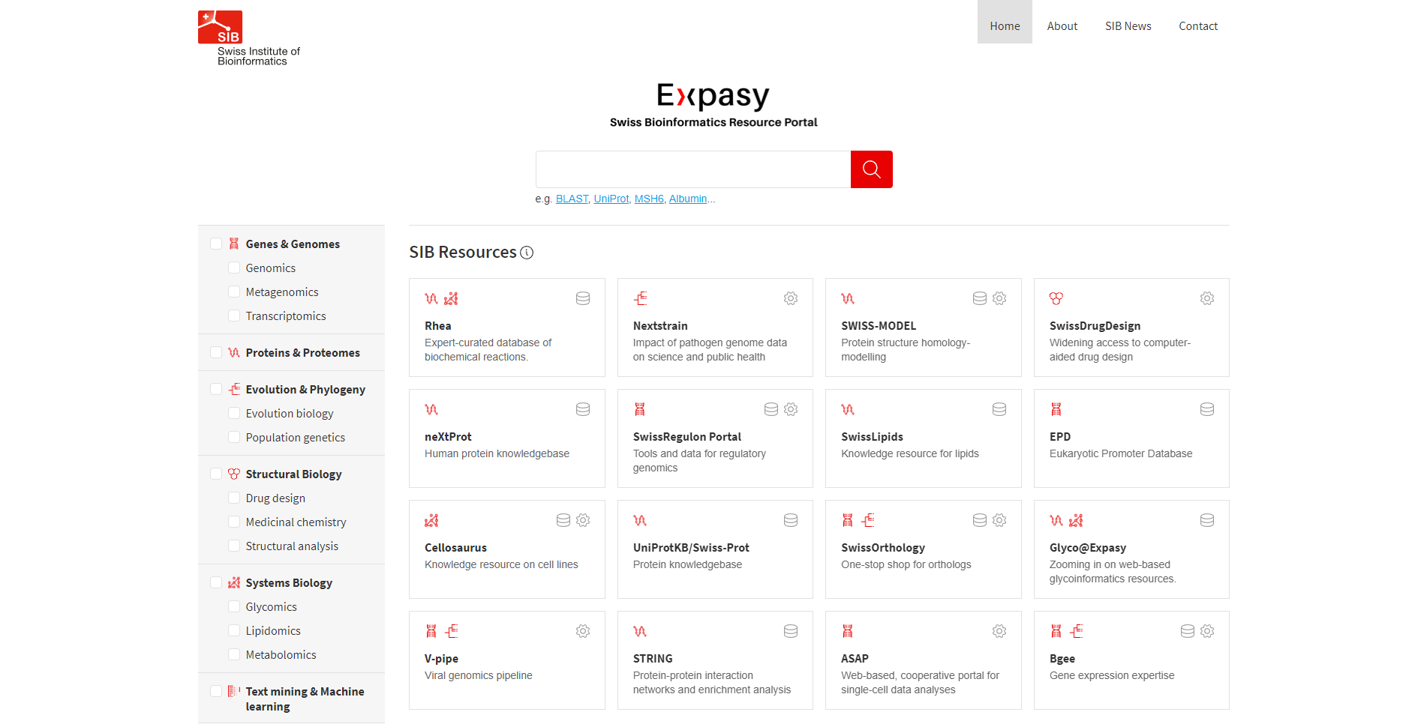Fig1: Homepage of ExPasy Tools.
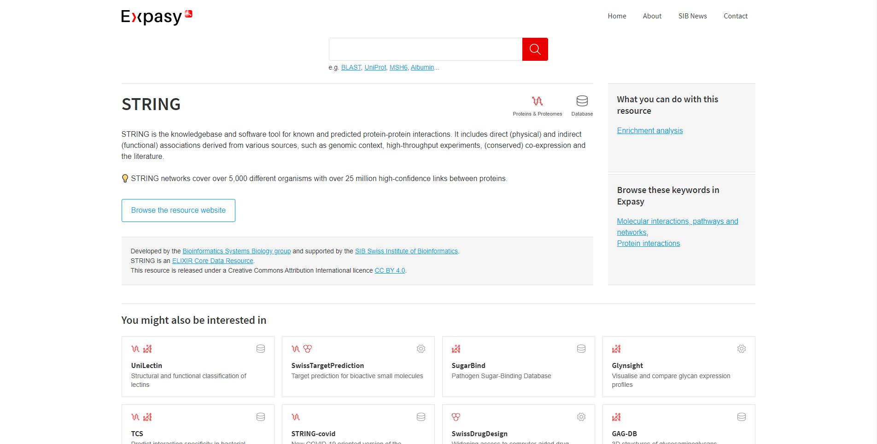Fig2. Hit page of String
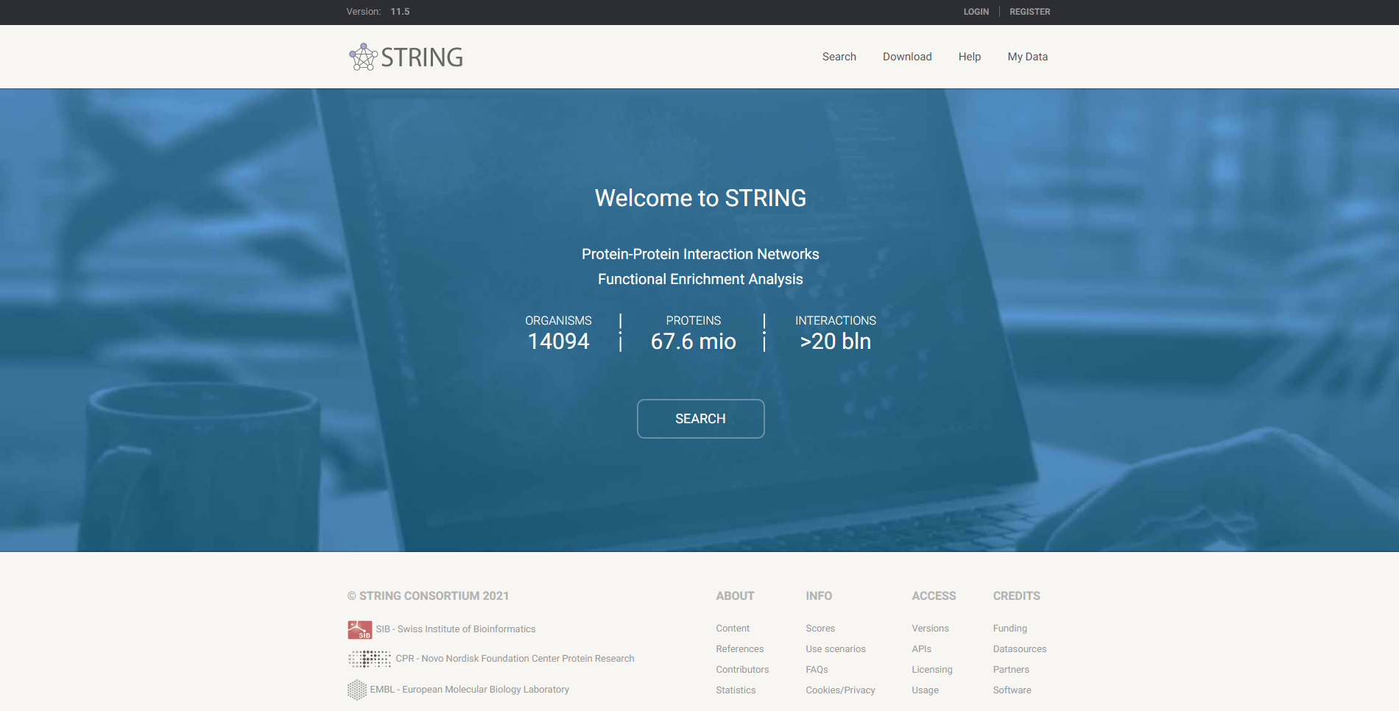Fig3: Homepage for String
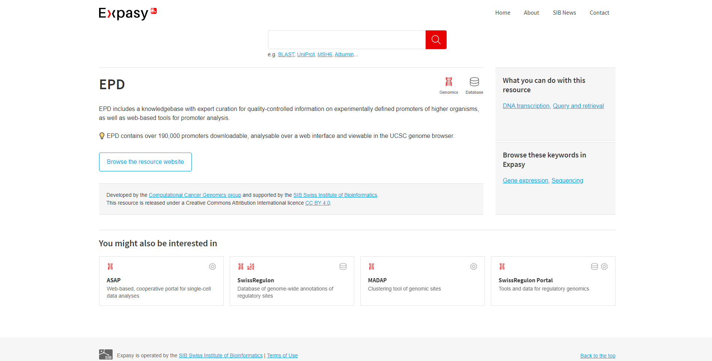Fig4: Hit page for EPD
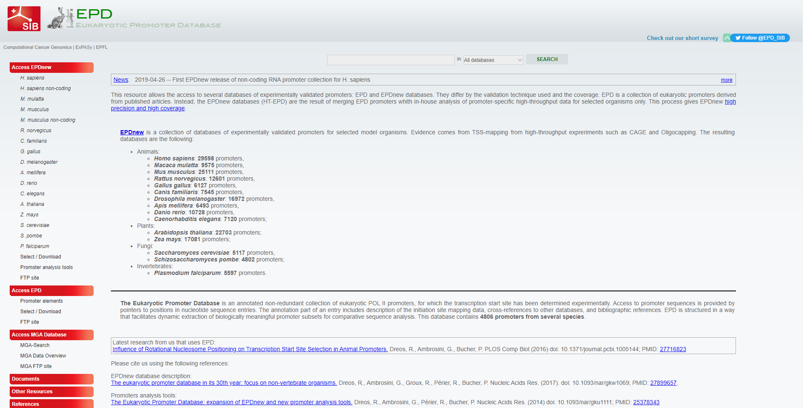Fig5: Homepage for EPD
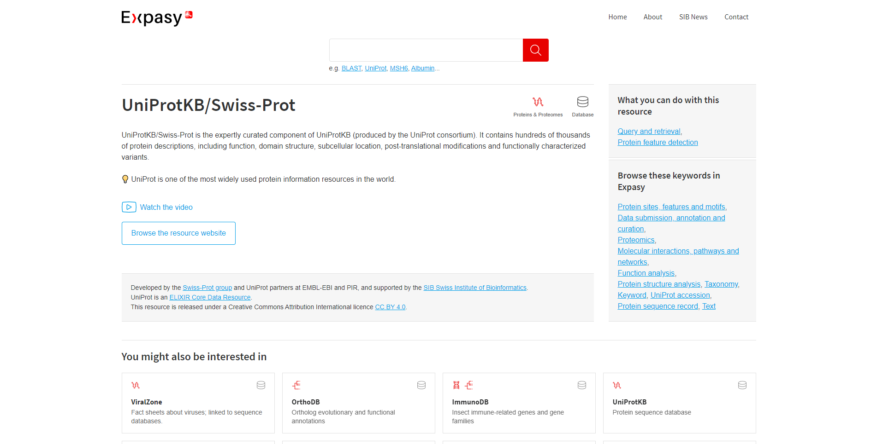Fig6: Hit page for UniProtKB/SwissProt
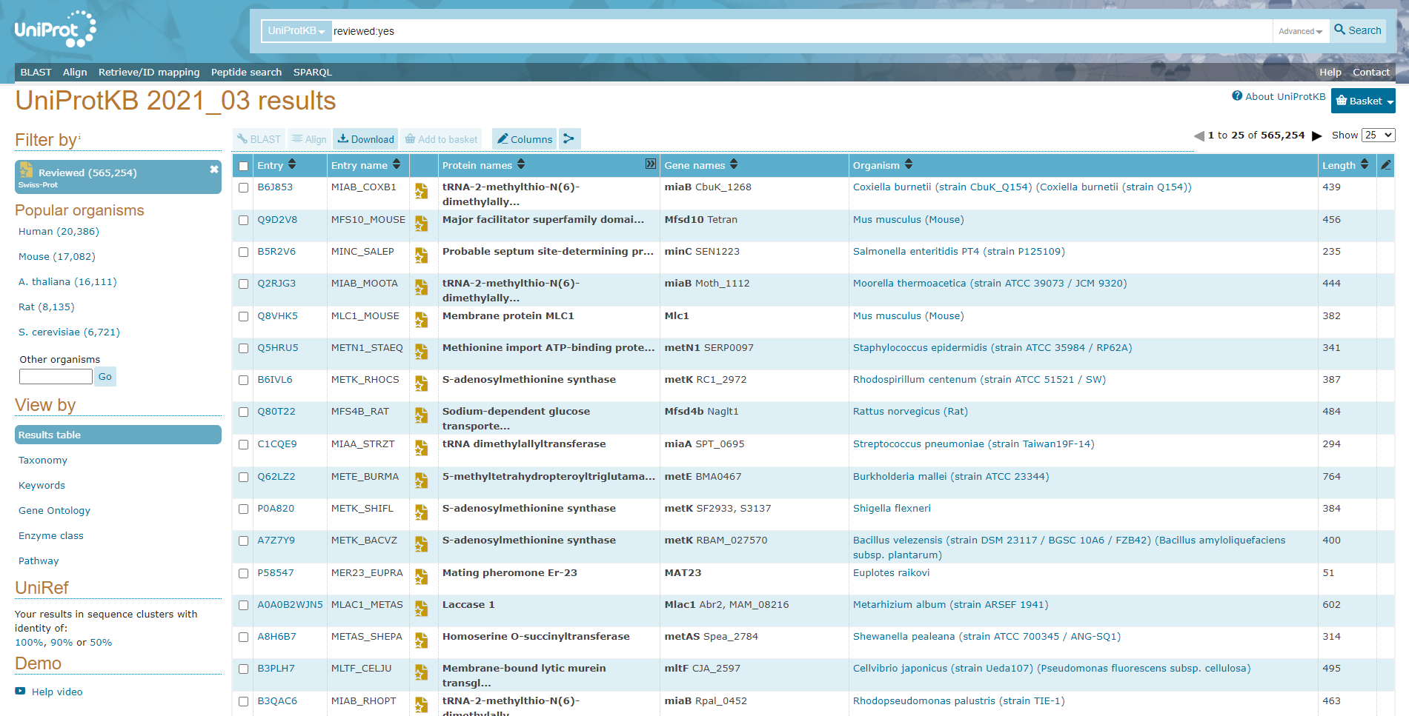Fig7: Homepage of UniProtKB

Results:
Expasy Tools:
It is an extensible and integrative portal which provides access to over 160 databases and software tools, developed by SIB Groups and supporting a range of life science and clinical research domains, from genomics, proteomics and structural biology, to evolution and phylogeny, systems biology and medical chemistry.

- STRING:
The STRING database contains information from numerous sources, including experimental data, computational prediction methods and public text collections. It is freely accessible and it is regularly updated. The resource also serves to highlight functional enrichments in user- provided lists of proteins, using a number of functional classification systems such as GO, Pfam and KEGG. The latest version 11b contains information on about 24,5 million proteins from more than 5000 organisms.
- EPD:
The Eukaryotic Promoter Database (EPD) is an annotated, non-redundant collection of eukaryotic Pol II promoters, for which the transcription start site has been determined experimentally. Access to promoter sequences is provided by pointers to positions in nucleotide sequence entries.

- UniProtKB:
Uniprot is a freely accessible database of protein sequence and functional information, many entries being from genome sequencing projects. It contains a large a large amount of information about the biological fuction of proteins derived from the research literatures.

Conclusion:
Expasy is an online bioinformatics resource operated by the SIB Swiss Institute of Bioinformatics. The individual resources (databases, web-based and downloadable software tools) are hosted in a decentralised way by different groups of the SIB Swiss Institute of Bioinformatics and partner institutions.

References:
  - (n.d.). Retrieved from https://epd.epfl.ch//index.php
  - EPD. (n.d.). Retrieved from https://www.expasy.org/resources/epd
  - SIB Swiss Institute of Bioinformatics. (n.d.). Retrieved from https://www.expasy.org/
  - STRING. (n.d.). Retrieved from https://www.expasy.org/resources/string
  - UniProt ConsortiumEuropean Bioinformatics InstituteProtein Information ResourceSIB Swiss Institute of Bioinformatics. (n.d.). UniProt Consortium. Retrieved from https://www.uniprot.org/uniprot/?query=reviewed:yes
  - UniProtKB/Swiss-Prot. (n.d.). Retrieved from https://www.expasy.org/resources/uniprotkb-swiss-prot
  - Welcome to STRING. (n.d.). Retrieved from https://string-db.org/

